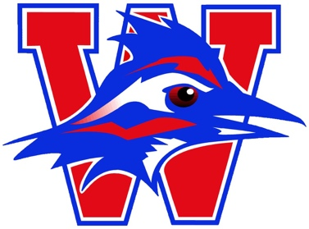

2019 VOLLEYBALL CAMP

Come to Volleyball Camp at Westlake High School this summer! This camp is for all ages and all levels, from beginner to advanced. The incoming 9th graders will get a good idea of what high school volleyball will entail, and will be challenged to develop their skills and volleyball IQ. The 7th and 8th graders will also develop their skills, volleyball IQ, and learn what they can do over the summer before middle school tryouts. We have many fun games planned for the younger age divisions, and will introduce them to the basic skills. Marci Laracuente is in her second year as the Head Volleyball Coach at Westlake High School and is looking forward to working with all the athletes in the Westlake community!

When: Monday, June 3rd – Thursday, June 6th, 2019

Sessions: 2nd-6th Grade: 8:00-10:00am *Sign up for the session of the grade
7th Grade: 12:30-3:30pm that your child will be entering for 8th Grade: 8:00-11:00am the 2019-2020 school year.
9th Grade: 12:30-3:30pm

Where: Westlake High School Competition Gym

***Registration opens on April 1st: https://eanes.augusoft.net/

